FTP Client

The File transfer protocol client (FTP client) is a software that is designed to transfer the data between a system and server on the internet. This software works when it is installed on your computer. FTP client software can only be used with the help of the internet.

It is based on the client/server architecture, where the host system is a client, and the remote server is a central server. FTP client helps a user to connect to a remote system. It allows data to be upload or download. The uploading or downloading of the data is very easy with the help of an [FTP](https://www.javatpoint.com/computer-network-ftp). The installation of the FTP Client depends on your OS (operating system). It is not a complicated process. There are three components of the FTP Client: the user interface, control process, and data transfer process. It supports different IP protocols such as SSH, FTPS (FTP over SSL), FXP (Site2site transfer), etc.

In addition, the [FTP](https://www.javatpoint.com/ftp-full-form) Client has some additional features.

* If the download fails for any reason, you can resume that downloading with the help of FTP client software.
* FTP client is very useful for those people whose internet speed is very slow.

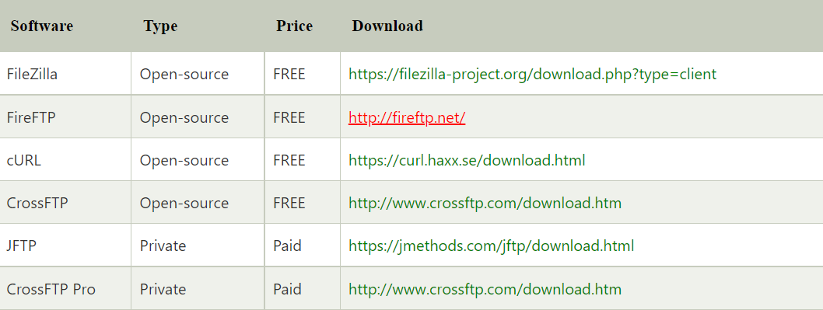FTP Client software for multi-OS:

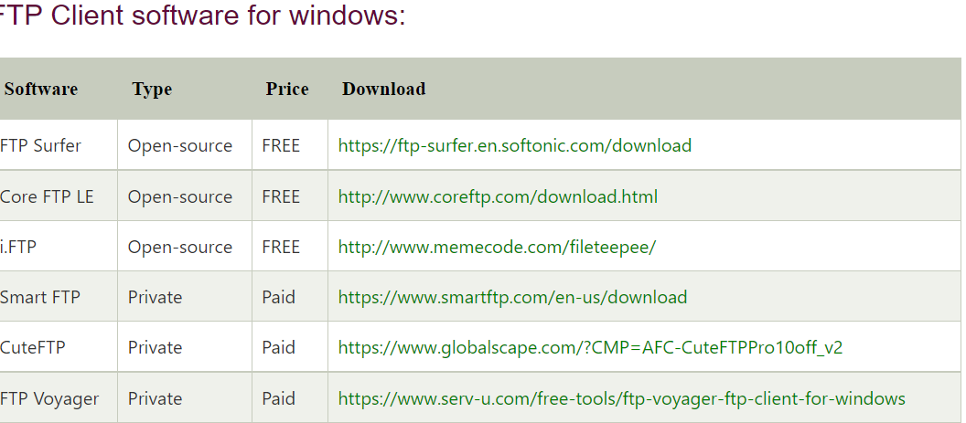

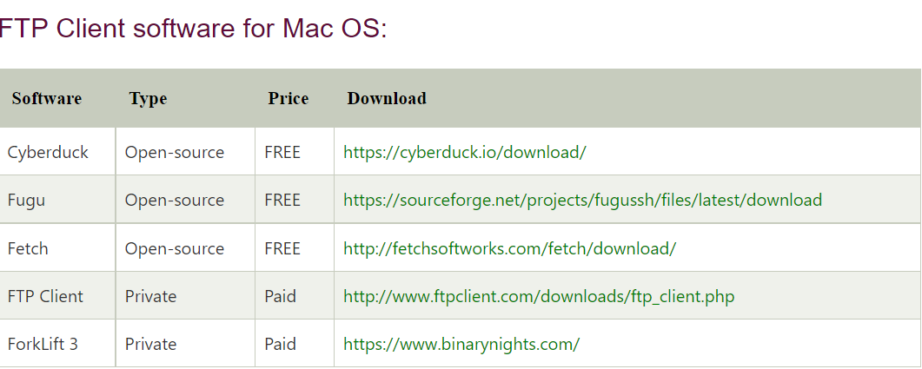

Login to FTP Client account:

If you want to upload your data to the server with the help of the FTP client, you must use the right login details, including your **FTP host_name, user_name,** and **password**.

Advantages of FTP Client

1. It allows for transferring multiple data as well as directories.
2. If the download fails, you can resume that downloading with the help of FTP client software.
3. It allows us to add the data to a queue to be upload or download.
4. It can transfer data to a specific schedule.
5. It provides fast speed than HTTP.
6. There is no size limitation on a single transfer.
7. FTP client is very useful for those people whose internet speed is very slow.
8. In this, several clients have scripting abilities via the CMD (command line).

Disadvantages of FTP Client

1. It does not send the data in encrypted form.
2. It is difficult to filter the active FTP connection on the local device (passive is preferred).
3. It is complex to scripts job.
4. The server can be malformed to send the file to random ports on unexpected devices.